Date: 02/04/2024
INSPECTION: Maharashtra State Board of Technical Education (MSBTE), Regional Office Chh. Sambhajinagar, Academic Monitoring Committee for Diploma in Pharmacy courceinspected the college. 1. Mr. Kiran Bhagwat Patil (Chairman), 2. Mr. Amol Ramdas Patil (Member) were committee members deputed by MSBTE regional office.

Photographs
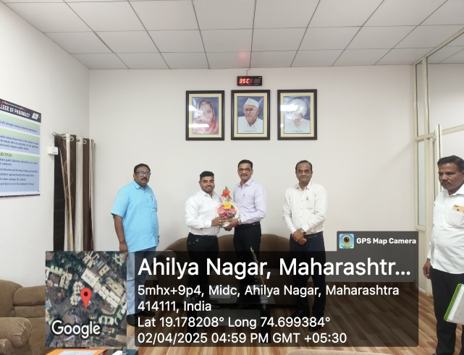 | 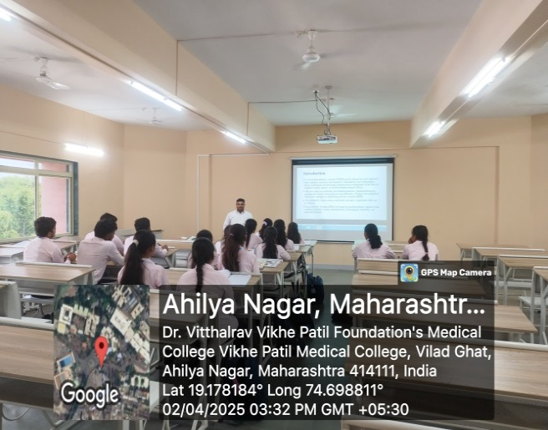
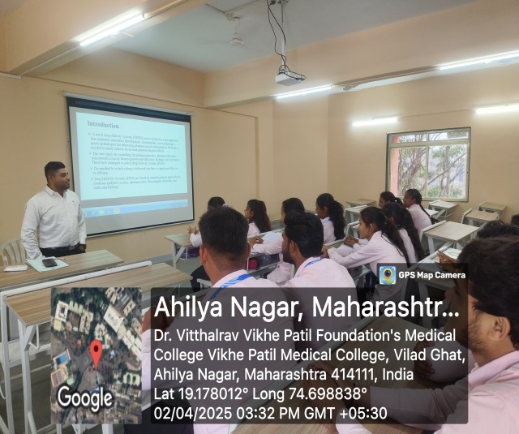 | 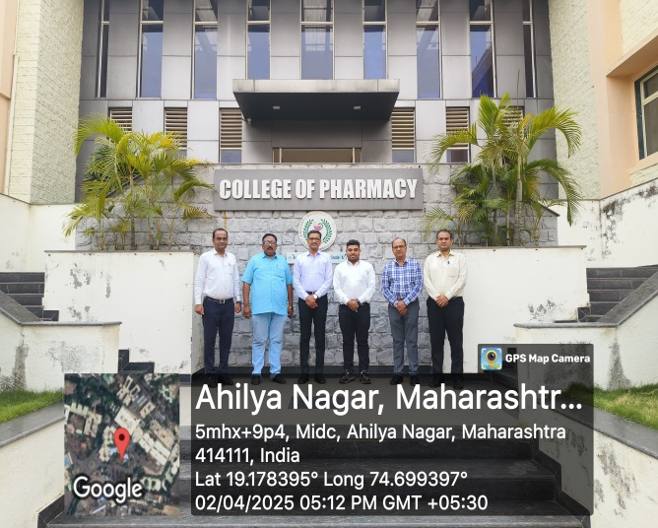

Date: 06/04/2025
SOCIAL ACTIVITY: Our college earn and learn students collected used items like cloths for childrens and kids shirts, pants, jackets, caps, gas burner, utensils, etc. from citizens of Ganj Bajar, Halwai Gallli, Ahilyanagar city. The material were collected for donation to orphans at Snehalaya as a part of social awareness campaign. Mrs. Aruna Goyal, (social activist) from Ahilyanagar assisted the campaign.

Photographs
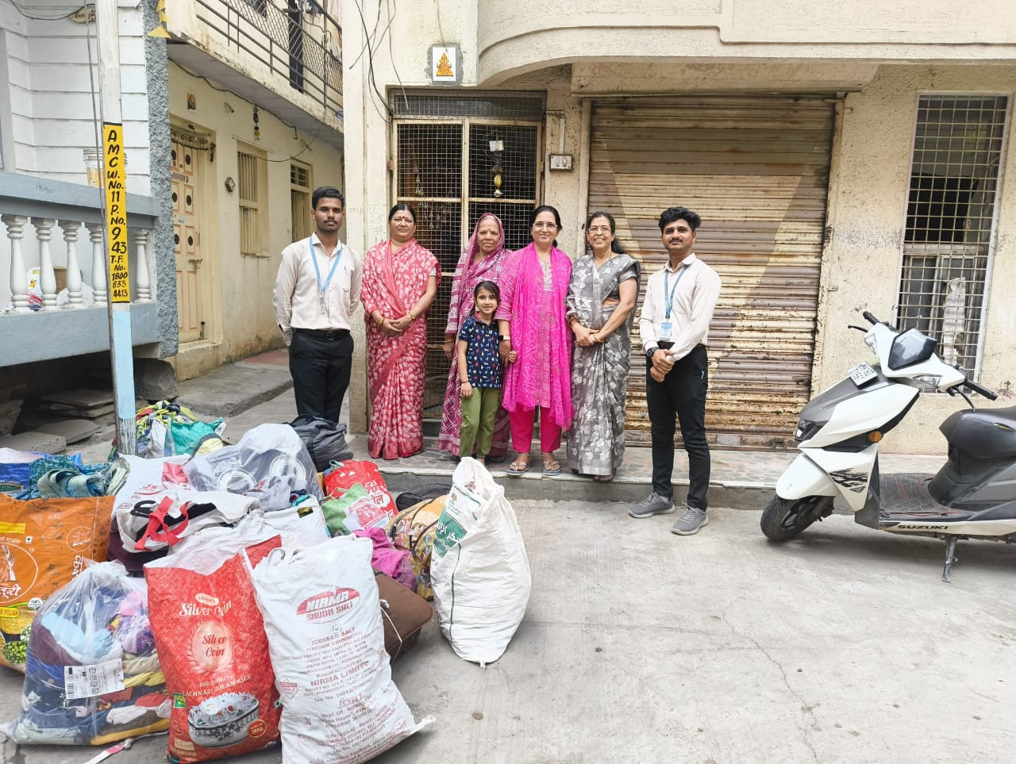

Date: 10/04/2025
PUBLICATION: Dr. Vikram V. Nimbalkar, Assitant Professor, Departement of Pharmacology and Dr. Ganesh D. Barkade, Assistant Professor, Department of Pharmaceutical Chemistry review article entitled “Repurposing of Mebendazole as an Anticancer Agent: A Review” has been published in Research Journal of Pharmacy and Technology (Scopus indexed journal). (ISSN:0974-3618;0974-360X)
https://www.rjptonline.org/AbstractView.aspx?PID=2025-18-4-23
Photographs
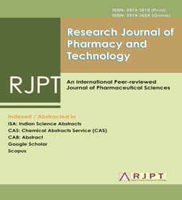 | 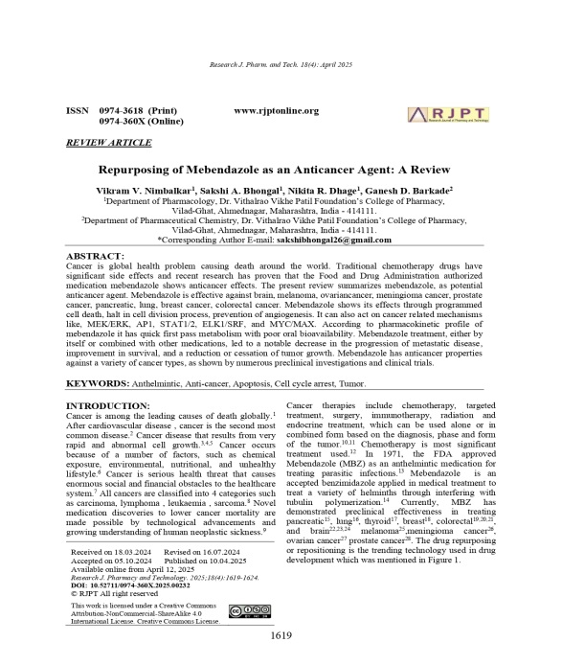
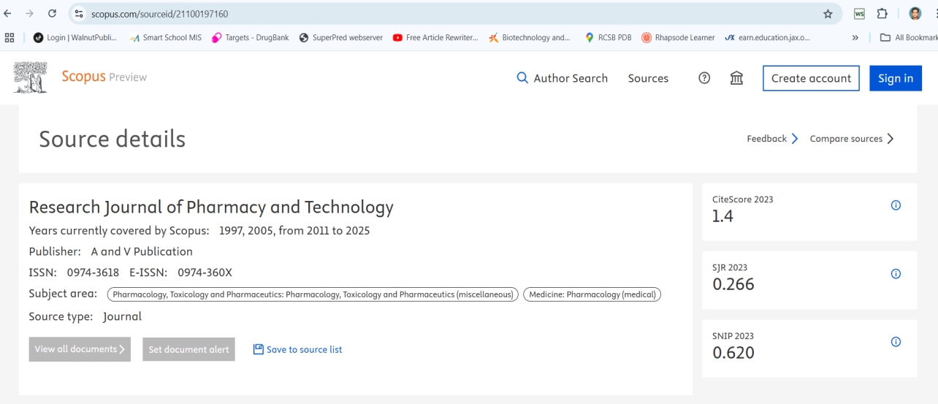

Date: 10/04/2025
FACULTY AS RESOURCE PERSON: Dr. Vikrant M. Dhamak, Assistant Professor, Department of Pharmaceutical Chemistry, delivered a session on topic “ Performing Annova Analysis using graphpad prism software” at Pravara Rural Education Society’s College of Pharmacy (for womens), Chincholi, Nashik.

Photographs
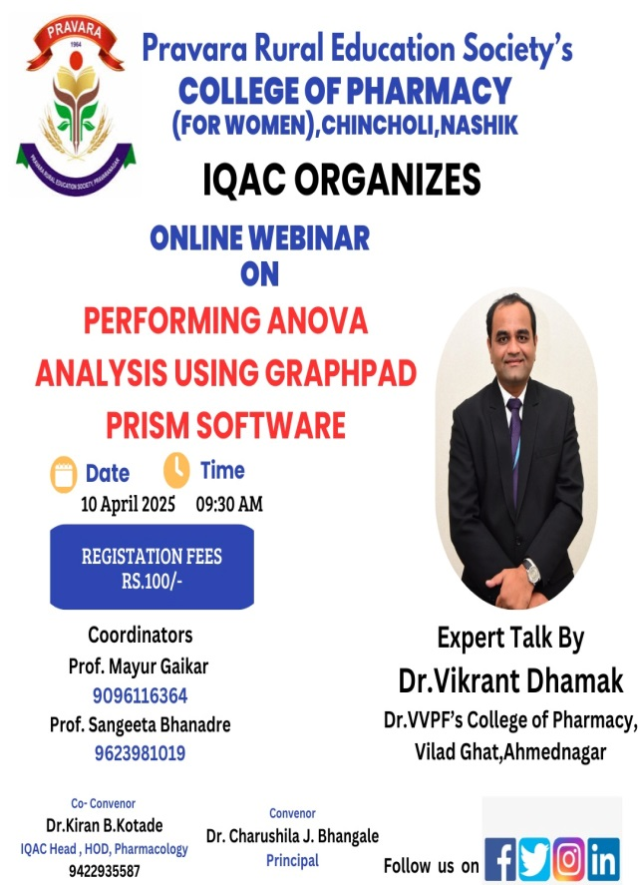 | 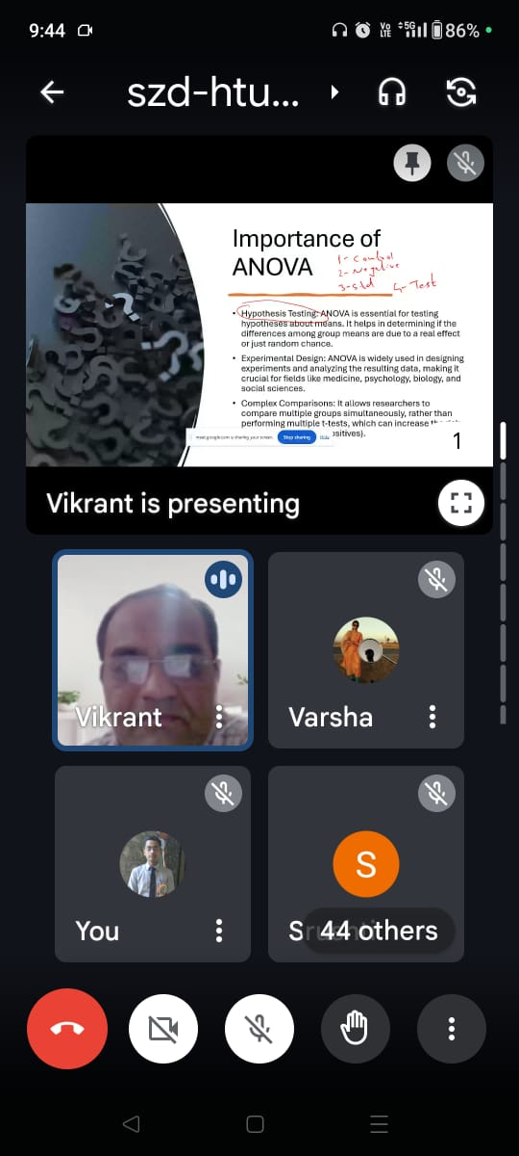

Date: 11&12/04/2025
FACULTY AS RESOURCE PERSON: Dr. Vikrant M. Dhamak, Assistant Professor, Department of Pharmaceutical Chemistry, delivered a session on topic “ Strategies for GPAT examination” in Cracking GPAT: A two day intensive workshop organized by Matoshri Radha College of D. Pharmacy, Virgaon, Akole, Ahilyanagar

Photographs
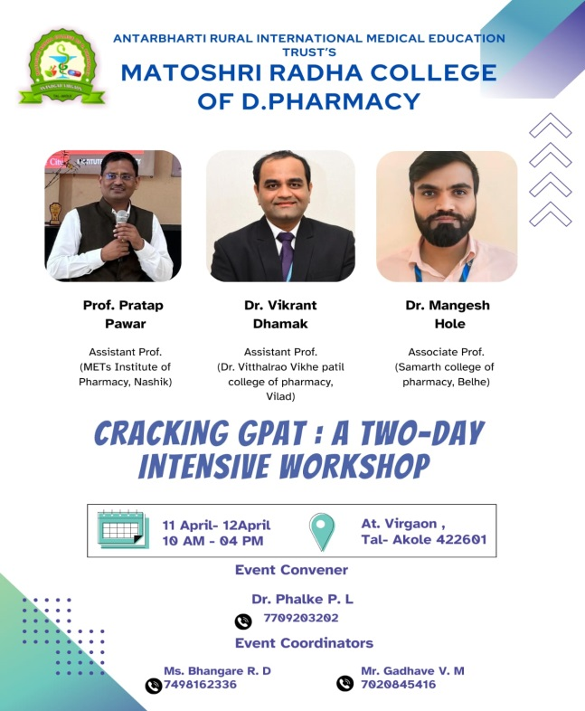 | 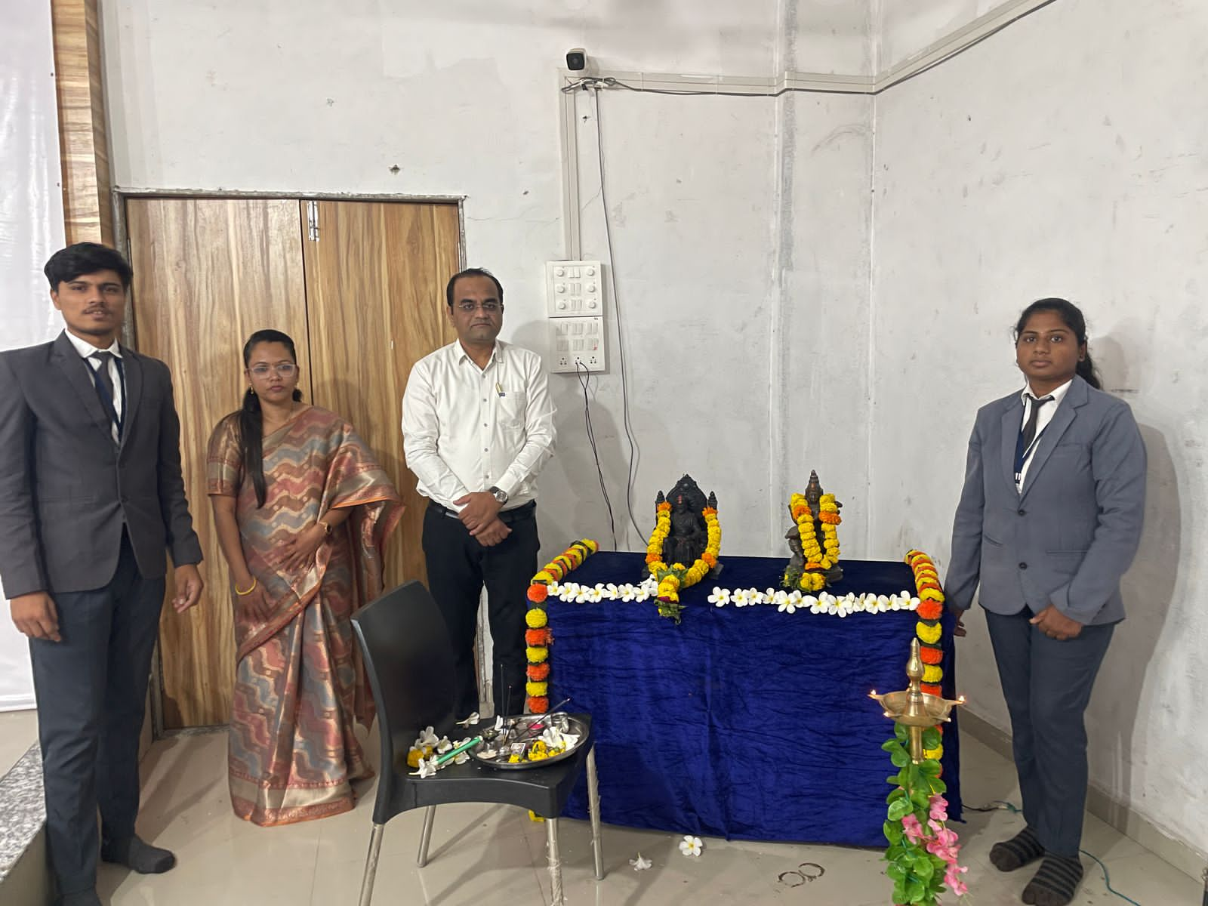

Date: 17/04/2025
ALUMNI VISIT: Our international alumni Mr. Rajesh Thorve, Senior Scientist, Analytical R & D, Bristol Laboratories Pvt. Ltd. New Castle, UK (Alumni of 2002-2006 Batch) visit to college. He was felicitated by Principal Dr. P. Y. Pawar Sir, later on he interacted with staff & students.

Photograph
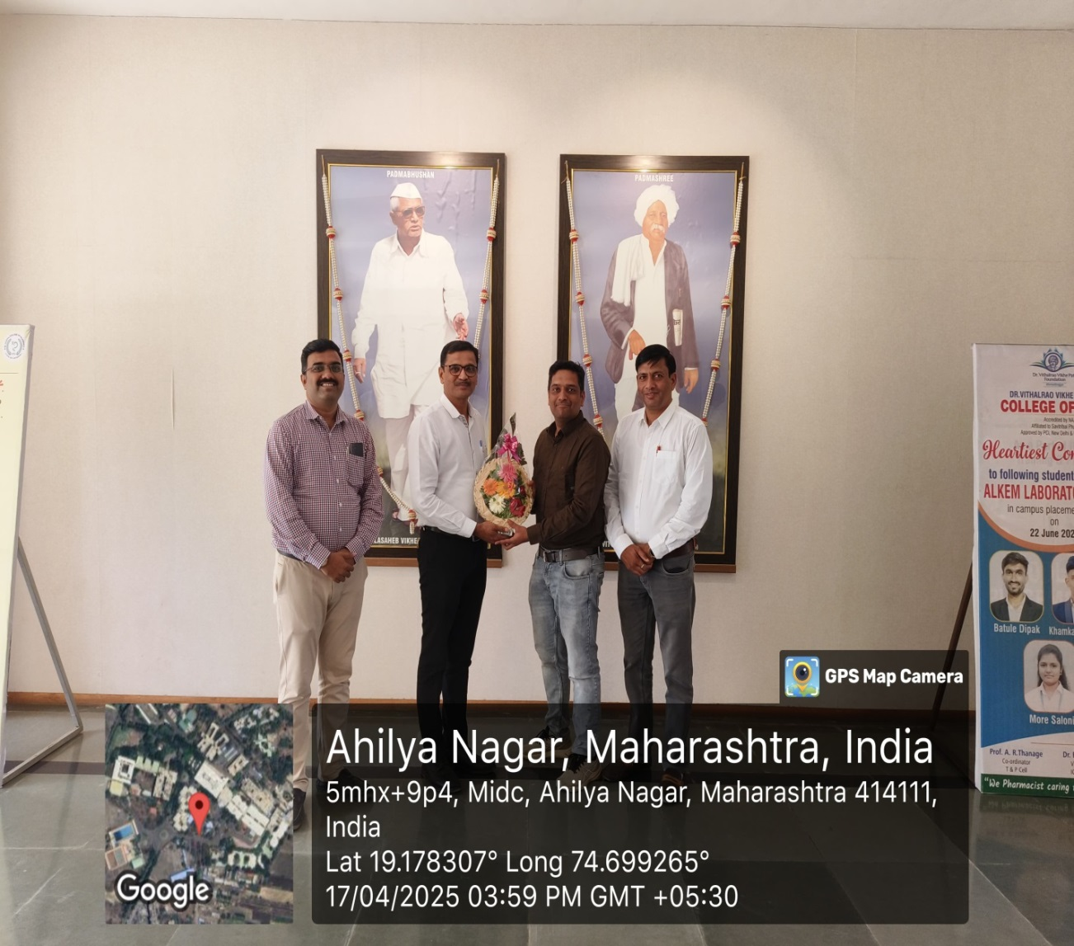

17/04/2025
BOOK EXHIBITION: Mobile Library (Book Van ) visited to college for book exhibition. All books of Swami Vivekanand were exhibited from 10: 00 am to 01:00 pm in parking area. Books were purchased by students and staffs from Mobile library.

Photographs
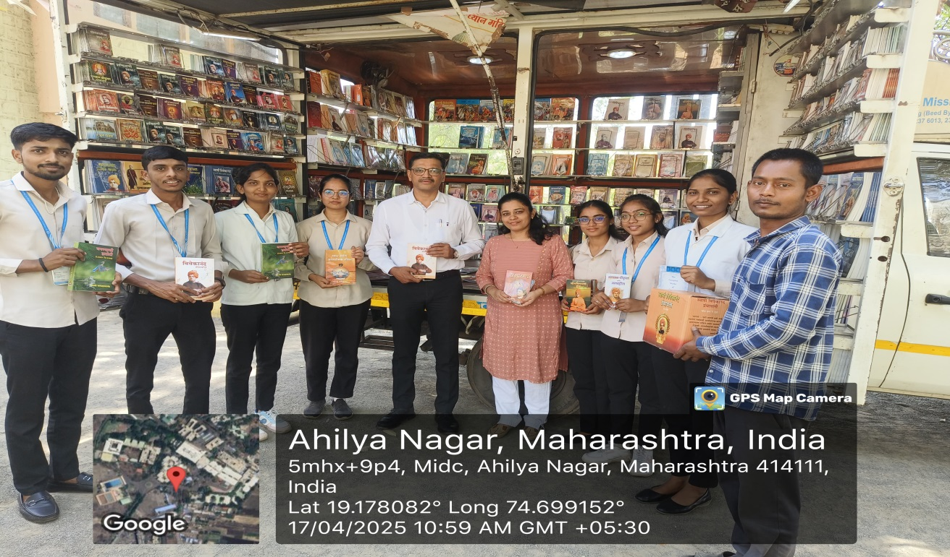
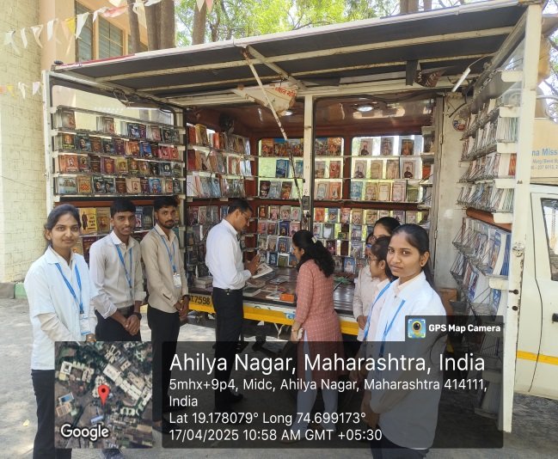 | 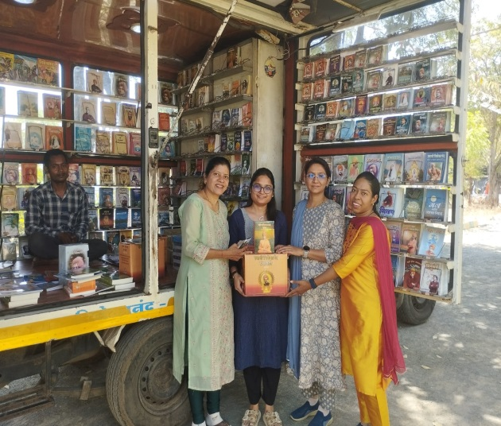

Date: 22/04/2025
GUEST LECTURE: An Guest lecture by Mr. Rupesh Chaure, HOD, GDC Latur, on topic "Career Guidance GPAT Exam Preparation & Development of Soft Skills" was organized for all Third Year B. Pharmacy students on 22nd April 2025.

Photographs
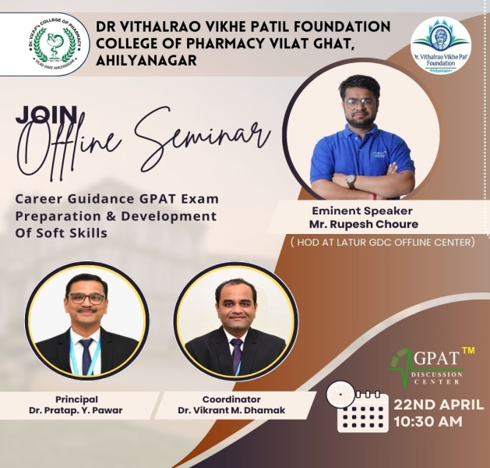 | 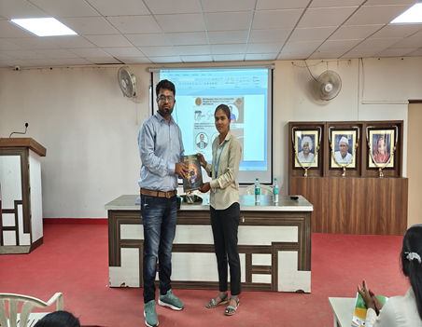
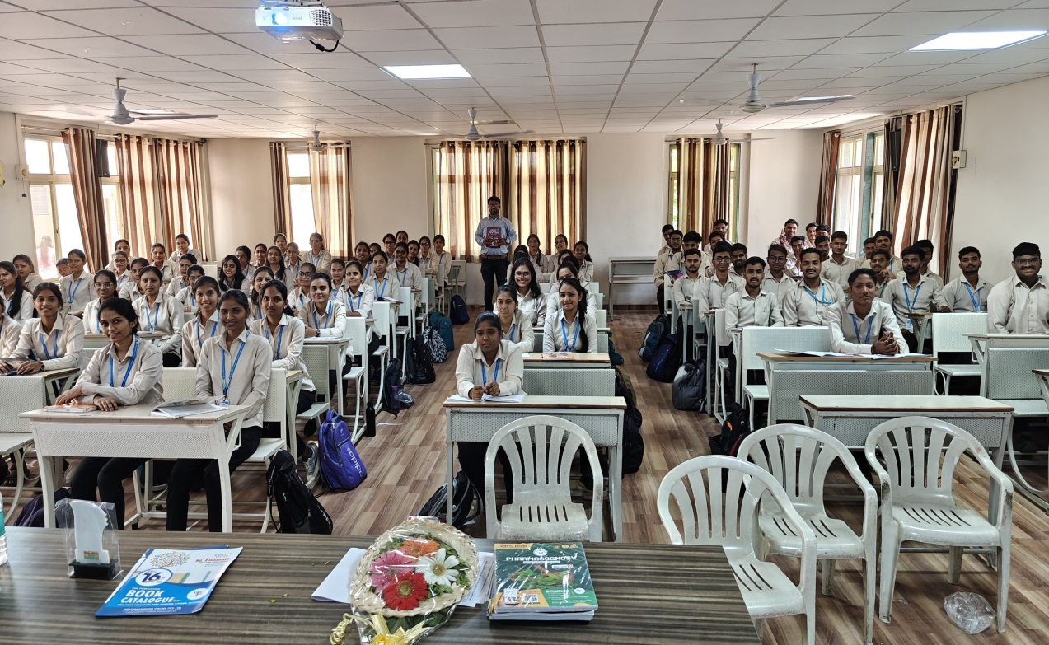

Date: 22/04/2025 to 25/04/2025
EXAMINATION: End semester theory examinations of First Year B.Pharmacy and First Year M. Pharmacy conducted as per Savitribai Phule Pune University Guidelines.

Photographs
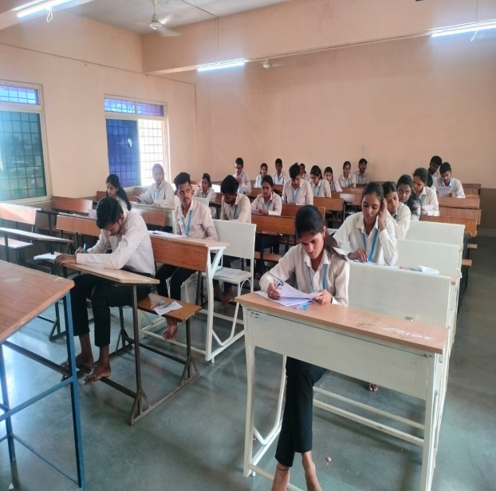 | 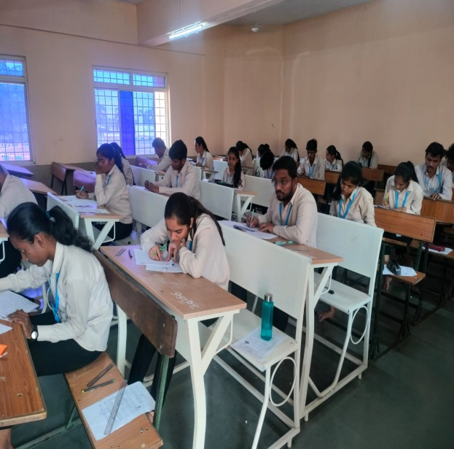
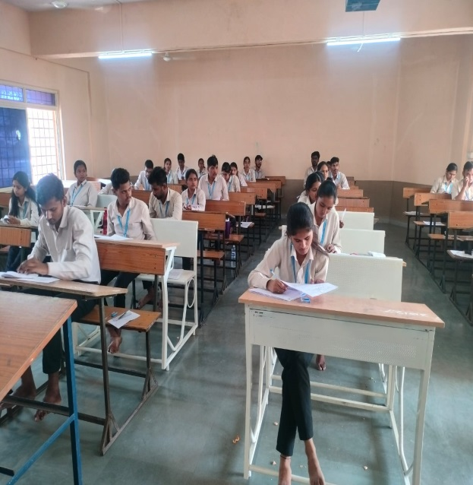 | 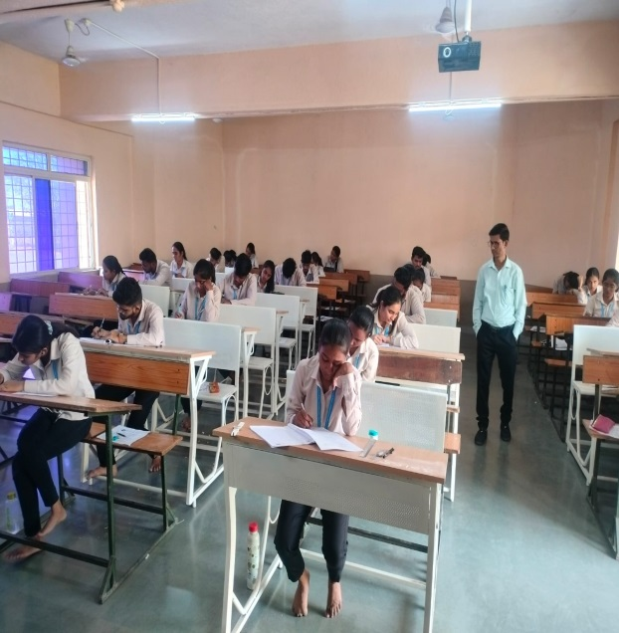

Date: 27/04/2025
PRATIMA POOJAN: Death Anniversary of Hon. Late Padmshri Dr. Vithalrao Vikhe Patil was observed in college. Tribute were offered to Late Padmshri Dr. Vithalrao Vikhe Patil by teaching and non-teaching staff.

Photographs
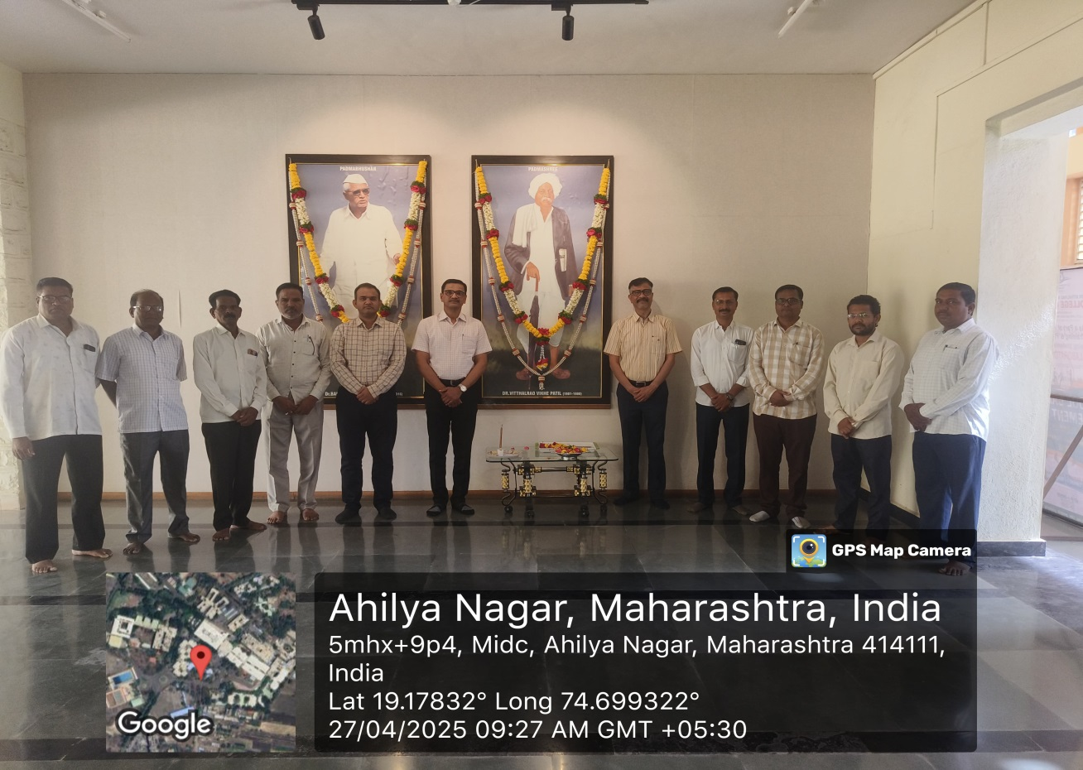

(Dr. Pratap Y.Pawar)
Principal
Forwarded through :-
The Director Technical,
DVVP Foundation,A’Nagar

