02/05/25
RETIREMENT: Farewell was given to Mr. Narayan Wakale, Peon, Department of Library after his retirement. He served the institute for 29 years.

Photographs
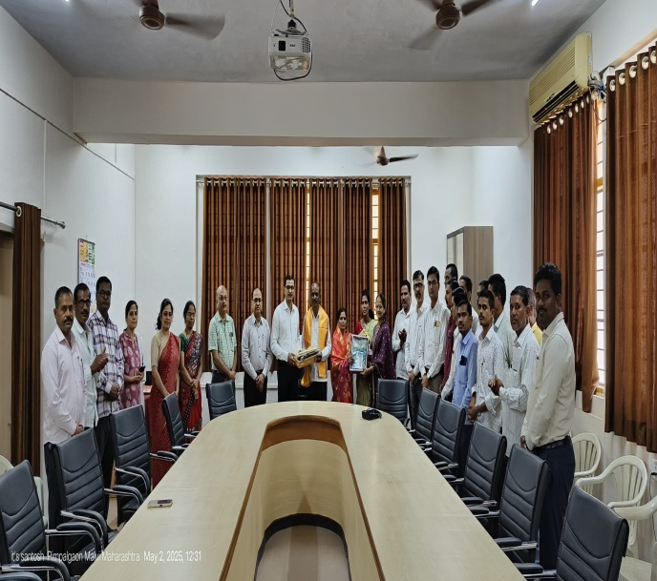 | 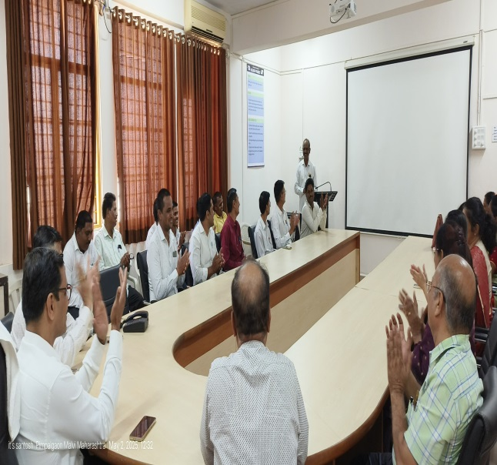

05/05/2025
BIRTH ANNIVERSARY: 93rd Birth anniversary of Loknete Dr. Balasaheb Vikhe Patil (Padmbhushan Awardee) was observed.

Photographs
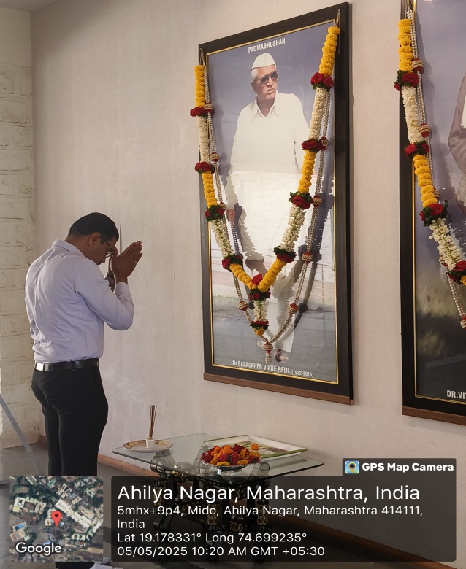 | 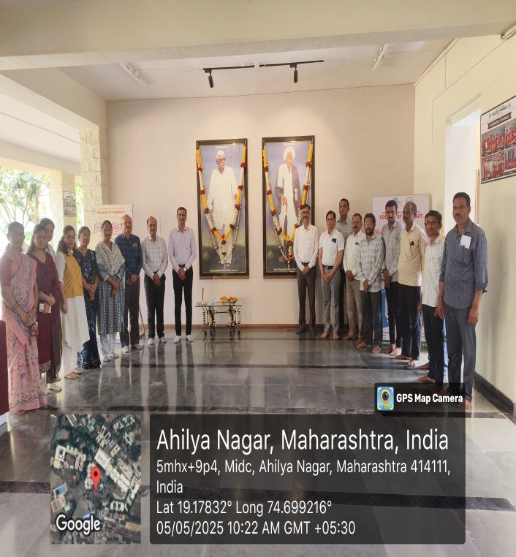

13/05/2025
PUBLICATION: Our Faculty Prof. Dr. Ramesh L. Sawant, Vice-Principal; Sr. Professor and Head of PG Studies, Prof. Jyoti B. Wadekar, Assistant Professor, Department of Pharmacognosy and Dr. Ganesh D. Barkade published their research article entitled “1,3-Thiazolidine-4-Ones” Copper Nickel Oxide Bimetallic Nanoparticles Catalyzed Synthesis, Anticancer Potential and Molecular Modeling Studies” in Russian Journal of Applied Chemistry (Publisher: Springer Nature) (Indexing: Scopus & Web of Science)

Photographs
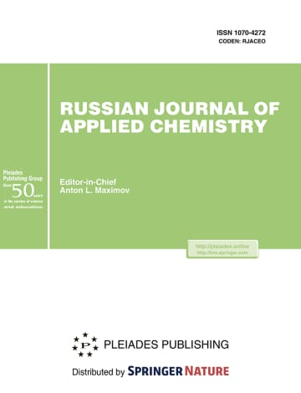 | 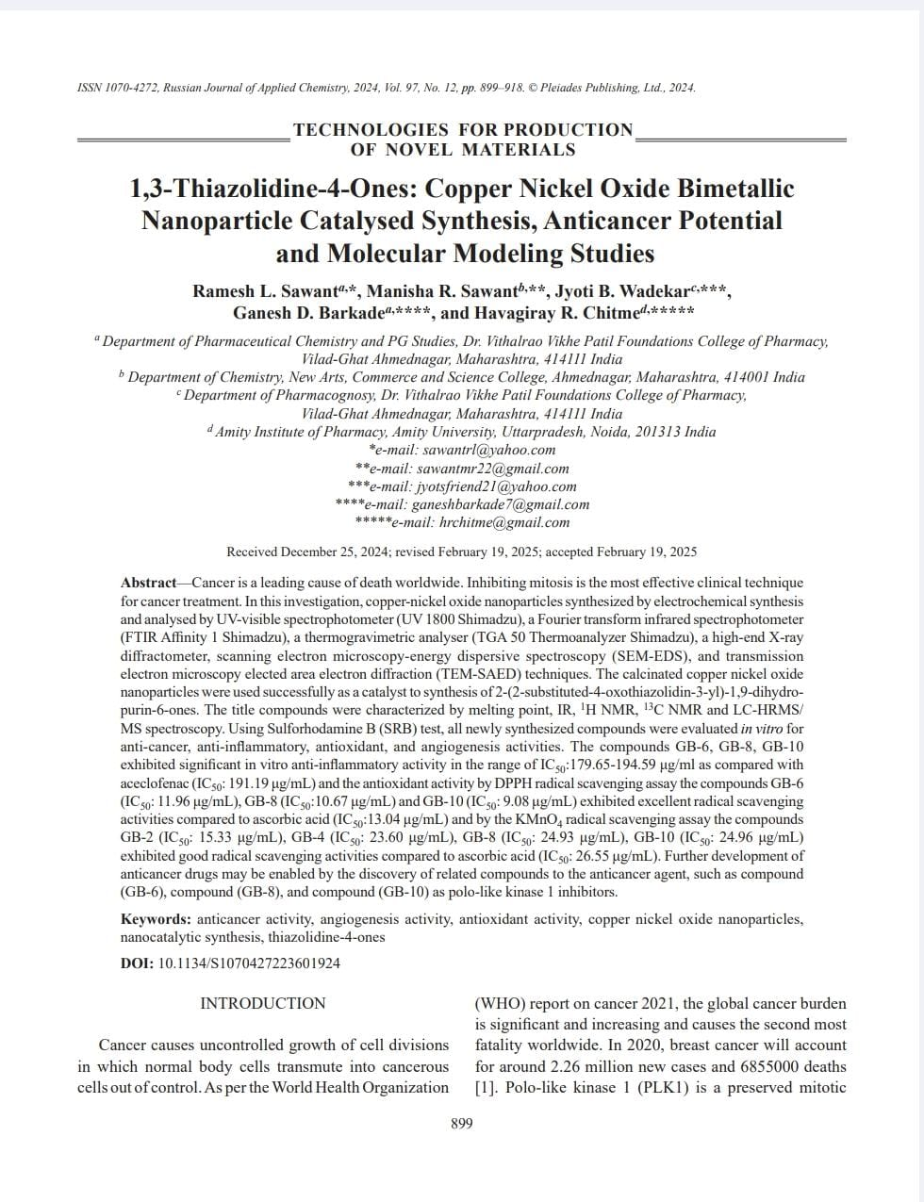

13/05/2025
ADMISSION: Ph. D. (Pharmaceutical Chemistry) admissions 2024-25 Ph.D. Topic approval presentation were conducted in presence of Research Advisory Committee (RAC). Dr. Sohan Chitlange, Principal, Dr. D. Y. Patil Institute of Pharmaceutical Education and Research, Pune was the External Subject Expert of RAC. Total 03 students were provisionally admitted in the Ph.D. Research Centre.

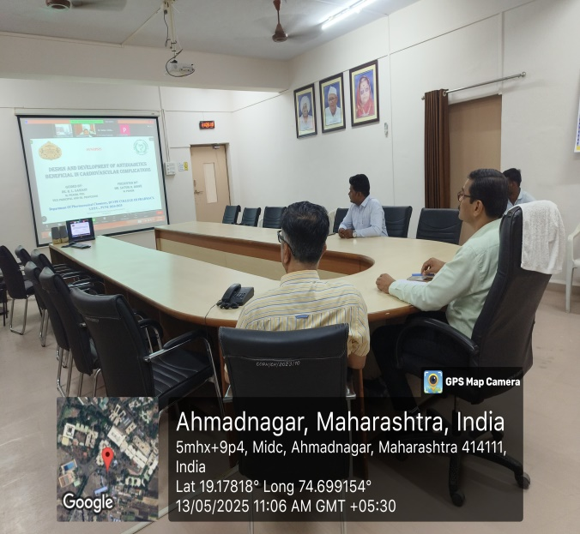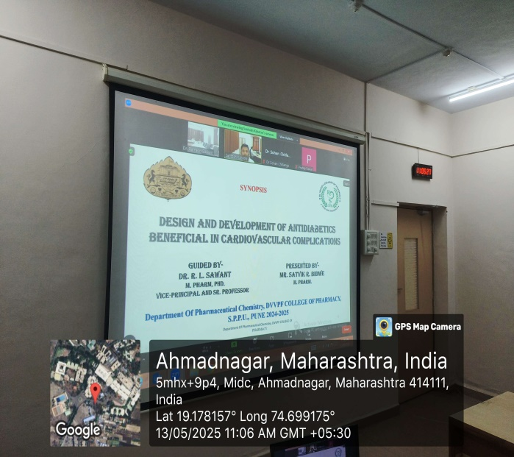

15/05/2025
ADMISSION: Ph. D. (Pharmaceutics) admissions 2024-25 Ph.D. Topic approval presentation were conducted in presence of Research Advisory Committee (RAC). Dr. Anil Pawar, Associate Professor, Department of Pharmaceutics, MES College of Pharmacy, Sonai was the External Subject Expert of RAC. Total 11 students were provisionally admitted in the Ph.D. Research Centre.
Photographs
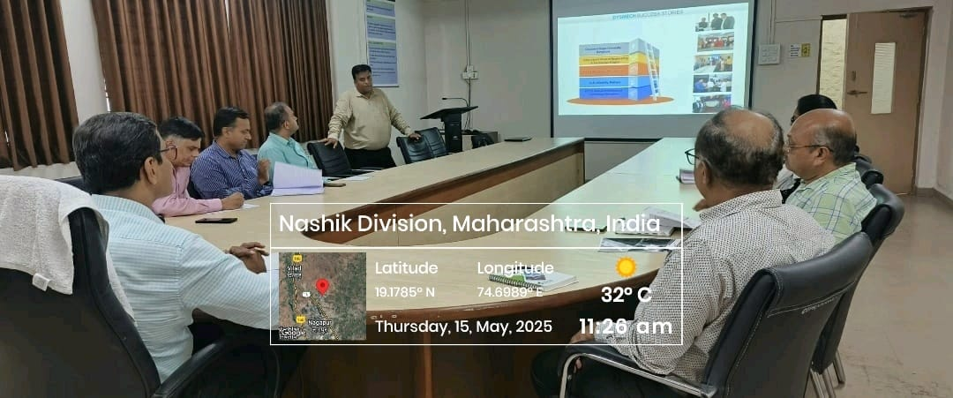

17/05/2025
PLACEMENT: Campus Placement Drive of Mylan Laboratories Limited (VIATRIS) for Indore, Chh. Sambhajinagar & Nashik location.
Photographs
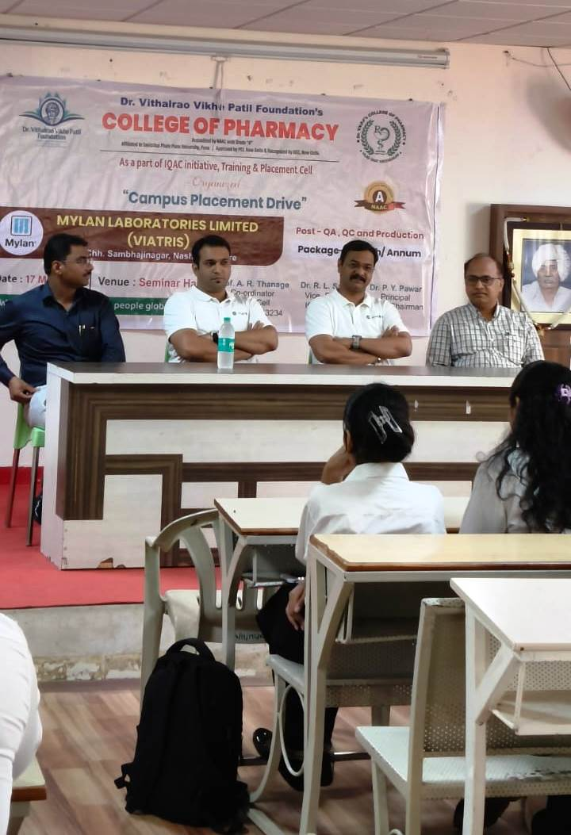

Photographs
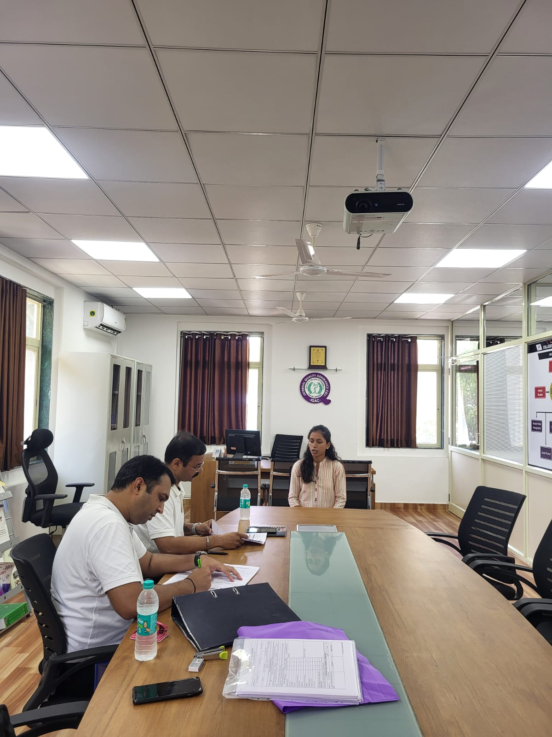

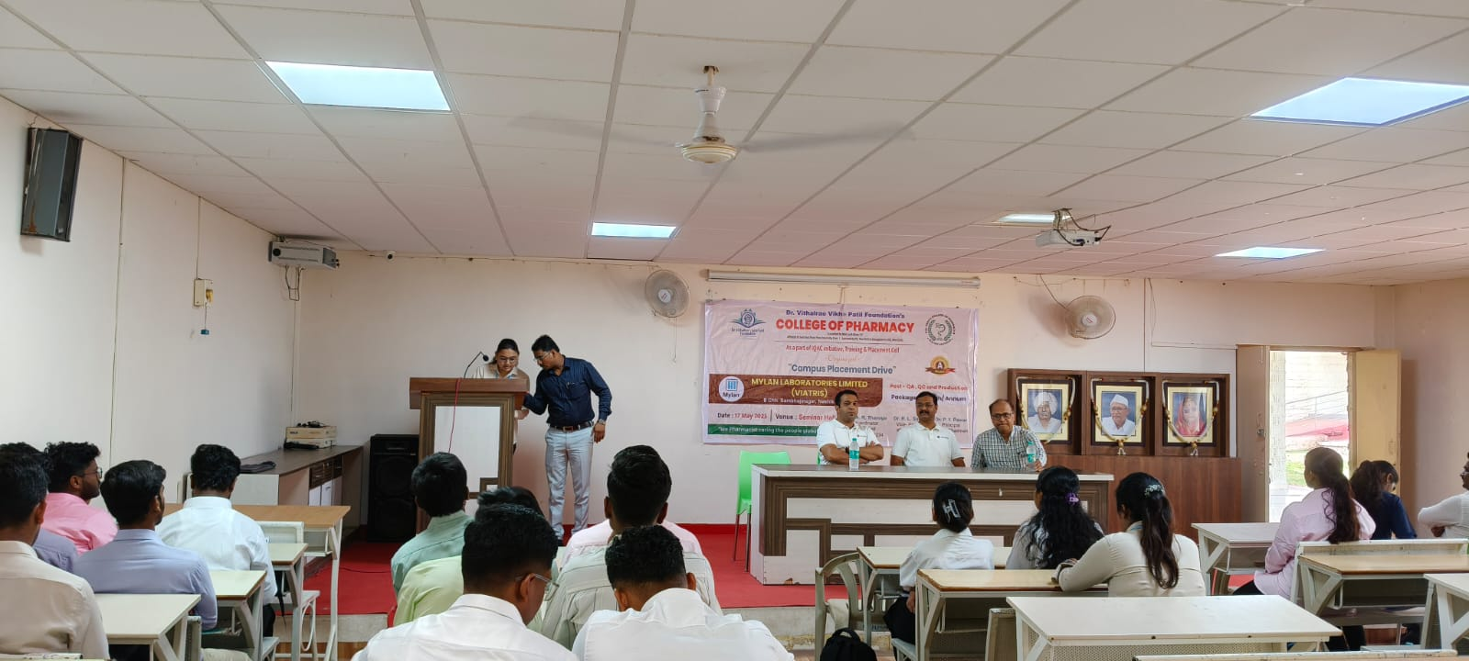

20/05/2025
CONDOLENCE: Sad demise of Mr. Raju Dethe, Peon, Animal House due to minor health problem. Condolence was paid to Mr. Raju Dethe by Principal, Teaching, Non-teaching and technical staff.

Photographs
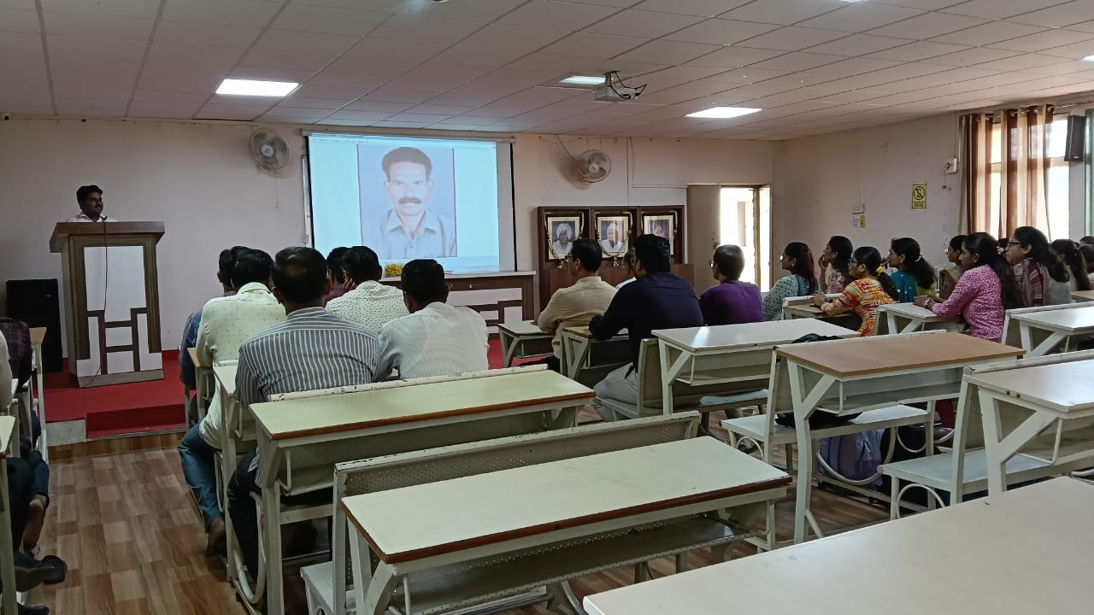 | 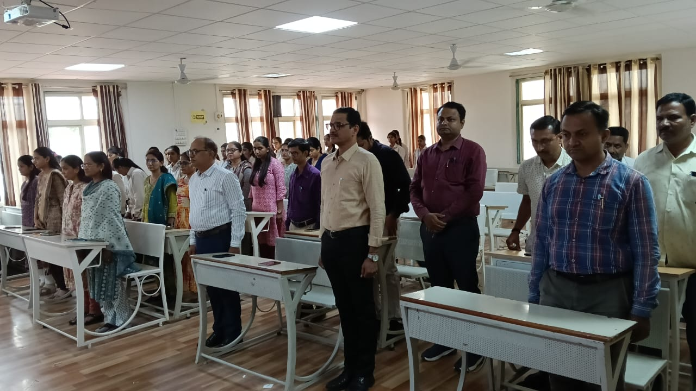

22/05/2025
ADMISSION: Ph. D. (Pharmacology) admissions 2024-25 Ph. D. Topic approval presentation were conducted in presence of Research Advisory Committee (RAC). Dr. Ramdas B. Phandhare, Department of Pharmacology, Associate Professor, MES College of Pharmacy, Sonai was the External Subject Expert of RAC. Total 05 students were provisionally admitted in the Ph. D. Research Centre.

Photographs
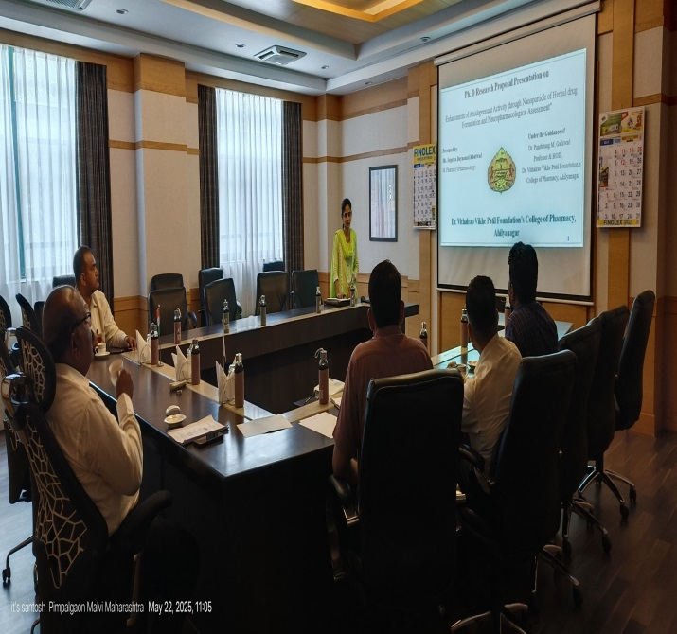 | 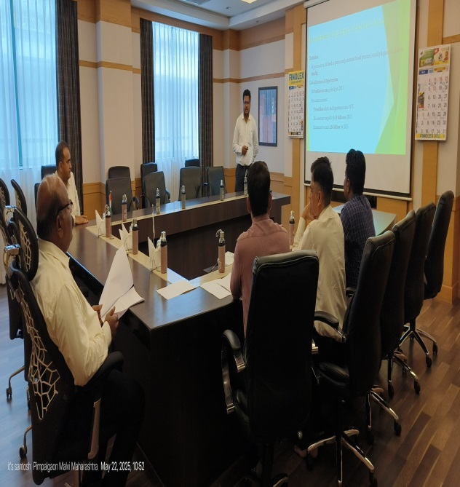

24/05/2025
COMMITTEE VISIT: Institutional Animal Ethical Committee (IAEC) visited to animal house and animal activity protocol presentations were approved successfully.
Photographs
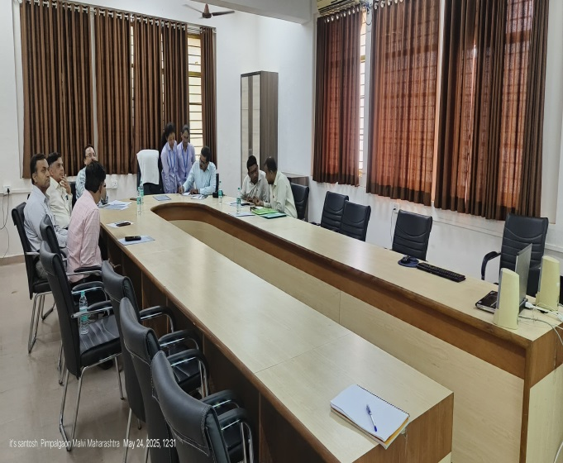 | 